Lab Sheet: Correlation and Regression Analysis with R
Objective: To measure the strength of relationships between variables and build predictive linear models using R.

1. Correlation Analysis (7 Minutes)
Correlation measures the strength and direction of the relationship between two variables.
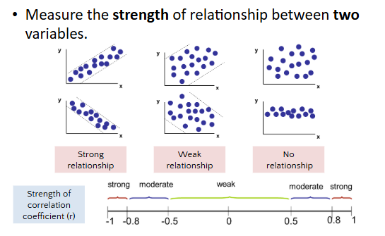
- Data Source: Refer to the data in lectureSEVEN #01 (e.g., Study Hours vs. GPA).
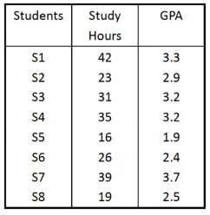
- Visualization: Before calculating, always view your data in a scatter plot using the plot() function to identify if a relationship exists.
- The Pearson Correlation Coefficient (r ): Use the cor(x, y) function to calculate the r value, which ranges from -1 (strong negative) to 1 (strong positive).
Exercise Snippet:
#Data: x = Study Hours, y = GPA
x <- c(42, 23, 31, 35, 16, 26, 39, 19)
y <- c(3.3, 2.9, 3.2, 3.2, 1.9, 2.4, 3.7, 2.5)

#1. Create a scatter plot with labels and limits
plot(x, y, xlim=c(0,50), ylim=c(0,5), xlab="Study Hours", ylab="GPA")

#2. Calculate the correlation coefficient
cor(x, y) #Default method is Pearson

2. Simple Linear Regression (8 Minutes)
Regression analysis is used to build a model that predicts a dependent variable (y ) based on an independent variable (x ).
- Data Source: Refer to the data in lectureSEVEN #02 (e.g., House Price vs. Square Feet).
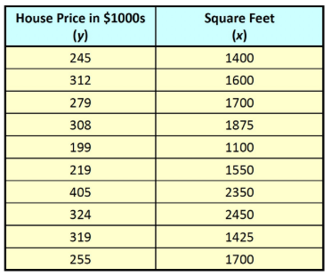
- Building the Model: Use the lm() (linear model) function. In R, the ~ symbol denotes a formula where y ~ x is equivalent to y=f(x).
- Inspecting the Model: Use summary(model) to view essential statistics, including the intercept, the slope (coefficient for x ), and the p-value to determine significance.
- Adding the Regression Line: Use the abline() function to overlay your regression model onto a scatter plot.
Exercise Snippet:
#Data: x = Square Feet, y = House Price ($1000s)
x <- c(1400, 1600, 1700, 1875, 1100, 1550, 2350, 2450, 1425, 1700)
y <- c(245, 312, 279, 308, 199, 219, 405, 324, 319, 255)

#1. Build the linear regression model
model <- lm(y ~ x)

#2. View model coefficients and statistical summary
model #Shows Intercept and x coefficient
summary(model) #Detailed results including R-squared and p-values

#3. Visualize the relationship with the regression line
plot(x, y, xlim=c(0,2600), ylim=c(0,500))
abline(model) #Adds the line based on the model

Quick Summary of Functions
- plot(x, y): Generates a scatter plot.
- cor(x, y): Calculates the correlation coefficient (r ).
- lm(y ~ x): Creates a linear regression model.
- summary(model): Displays the detailed statistical summary of the model.
- abline(model): Adds a regression line to an existing plot.
Note: Ensure your variables x and y have the same length before running these functions, or R will return an error.

